Converting of a University Teaching Unit

into a Computer Game (Gamification)

A REPORT SUBMITTED TO MANCHESTER METROPOLITAN UNIVERSITY FOR THE DEGREE OF BACHELOR OF SCIENCE

IN THE FACULTY OF SCIENCE AND ENGINEERING



2023

By Owen Clifford Park

Department of Computing and Mathematics

# Contents

**List of Tables 3**

**List of Figures 4**

Abstract 5

Declaration 6

Acknowledgements 7

Abbreviations 8

1. Chapter 1 – Literary Review 9

1.1 Literary Review **9**

1.2 Referencing **12**

1. Chapter 2 – Requirements 13

2.1 Requirements Table 13

1. Chapter 3 – Project Management 16

3.1 Jira 16

1. Chapter 4 – Design and Development xx

4.1 Paper design document drafts xx

4.2 The game world in Unity xx

4.3 Menu Design and Implementation xx

4.5 Design Extras

1. Chapter 5 – Videos xx

5.1 Introduction Video of project and design xx

5.2 Baseline Game World xx

5.3 Mechanics xx

5.4 Door Failure

5.5 Working Doors xx

6 Chapter 6 – Testing xx

6.1 Play testing xx

6.2 Bugs and fixes xx

7 Chapter 7 – Evaluation xx

7.1 Paper design document drafts xx

References xx

* 1. The first appendix xx
  2. The second appendix xx

Bibliography xx

# List of Tables

1.1 Requirements Table . . . . . . . . . . . . . . . . . . 2

# List of Figures

1.1 Sprint 1 1

1.2 Sprint 2

1.3 Sprint 3

1.4 Sprint 4

1.5 Sprint 5

1.6 Sprint 6

1.7 Sprint 7

1.8 Sprint 8

1.9 Sprint 9

2.0 Design on paper page 1 2

2.1 Design on paper page 2  2

2.2 Design on paper page 3 2

2.3 Design on paper page 4 2

2.4 xx

2.5 xx

2.6 xx

2.7 xx

2.8 xx

2.9 xx

2.10 xx

2.11 xx

2.12 xx

2.13 xx

2.14 xx

2.15 xx

2.16 xx

2.17 xx

2.18 xx

2.19 xx

2.20 xx

2.21 xx

2.22 xx

2.23 xx

2.24 xx

2.25 xx

2.27 xx

2.28 xx

2.29 xx

2.30 xx

# Abstract

The abstract is a formal description of the reason for doing this work, the methods used and results found, and the conclusions drawn. It should not be more than one page in length.

WRITE AT THE END

This study was produced to test how feasible converting a university module into a videogame would be. With the plan of teaching Foundation Mathematics (for computing) in an unconventional way. Seeing if the gamification of an entire module is something that could be effective in the way of teaching, as then others could explore if their subjects could be dealt with in a similar fashion, lessening the workload on tutors and making subjects more fun and engaging for students.

# Declaration

No part of this project has been submitted in support of an application for any other degree or qualification at this or any other institute of learning. Apart from those parts of the project containing citations to the work of others, this project is my own unaided work. This work has been carried out in accordance with the Manchester Metropolitan University research ethics procedures and has received ethical approval number 52891.

Signed:

Date:

# Acknowledgements

The acknowledgements thank the people who helped you do the work. It’s traditional to include your supervisor....

# Abbreviations

PCA Principal Components Analysis LTA Three Letter Acronym

# Chapter 1 – Literary Review

When asked about the earliest case of a videogame, people typically think of the Atari game, Pong (Centre for Computing History, 2023), but this is not the case. Firstly, computers were needed before videogames can even be made, and this happened during World War II where the first computers, the Colossus and Electronic Numerical Integrator and Computer (ENIAC) were built (Ceruzzi, J. 2003). After the war, computers such as the Manchester Mark I entered the mix and eventually, with a few more prototypes and computer designs, the first videogames were born. Now, there is no real way of telling which videogame was the first in the world, but Bertie the Brain’s OXO (Tic-Tac-Toe) from the 1950’s is viewed as one of them (Wolf, M. 2012). Back when these games were being produced, they weren’t commercially available and were only able to be ran on computers that, in those times, were the size of entire rooms. In comparison to popular games today, such as Fortnite (Epic Games, 2017) or the Sonic the Hedgehog series (1991 to present), which can be played on a number of consoles from PC to tiny handheld consoles, it is amazing to see how far gaming has come since this simple game of Tic-Tac-toe programmed specifically for the goliath that is the EDSAC.

Nowadays gaming is not only a popular pass time but a staple in many people’s lives. Starting as a “boy’s club” that catered its games and advertisements dominantly to a male audience; from highly sexualised adverts to guns, fast food, and overly masculine stereotypes (JBRogerThat, 2021). Once the internet became more popular and available for the regular person, the ability to share gaming ‘tips and tricks’ worldwide, and the invention of online gaming, gaming culture started to expand over time. It is used for socialising, stress relief, winding down after a long day at work, and has even been played as a sport (Esports) since Walter Day made their famous database of score keeping in 1982 (Day, XXXX). From arcade machines, consoles (both home and hand-held), gaming computers, mobile games and even gambling machines, it is becoming impossible to meet someone who have never played some form of videogame before. The popularity of videogames worldwide can easily be seen as it is estimated that 169.2 billion dollars in 2020 alone was spent on games, with an estimate of nearly 300 billion dollars to be spent on gaming by 2027(money spent ref). If this continues, it is not surprising that something such as Gamification would be explored and developed upon as a viable educational resource.

Gamification is the process of teaching a subject or a skill with the use of a videogame. Typically, by adding game-like elements to some form of training to encourage participation (dictionary ref). As it is the process of using game mechanics to learn non-gaming skills or being taught new information, keeping up engagement from the user is essential, to ensure the training is not only completed but for the information to stick, known as ‘intrinsic motivation’ (valamis games ref). This might not sound initially appealing, as videogames have always been seen as a leisure activity and gaming is stereotyped as outlets for procrastination. Often gamers themselves are seen in a negative light, lazy, jobless and with bad hygiene. So, using a videogame in the first place looks like a bad investment but learning techniques that are fun, or entertaining, can have benefits. There have been several fairly recent studies on engaging learning methods. One study explored learning in the classroom, with a comparison to how students felt they performed and how well they actually performed when given an active and engaging class or when given traditional lectures (Deslauriers, L. et al. 2019). The study shown that students felt as though they had learned more when being in the traditional lectures, in comparison to the actively engaging classes, when in fact the tests that were done after each lesson had higher scoring results in the activity ladened sessions compared to the traditional approach. Similar results with a study by Aji, C. and Kahn, J. (2019) where the active learning of maths caused an increase of 20% higher grading compared to their traditional routes.

Active learning, learning that is more positive and fun, is a staple of Gamification. If students using engaging studying can cause an increase in test results, it is useful to explore a variety of options that can be incorporated in more than just research studies. As already mentioned, gamification is used for work training. A positive result to using Gamification is that it not only streamlines work training, but with the use of examinations or pop quizzes throughout the training, it can also help employers to establish any knowledge gaps and adjust accordingly.

There are some rather successful gamification examples already in the world, but instead of traditional education they tinker in the training of new colleagues at workplaces. The most famous example being the VR game ‘KFC The Hard Way’ (KFC, 2017), where the player is in a VR KFC kitchen, needing to cook chicken correctly, before being allowed to leave. With the fun elements of a cooking simulation and some witty jokes, it teaches employees how to do their workload without feeling talked down to and without bored learning the basics of the job.

For educational subjects unrelated to a job role, applications such as Rosetta Stone (RS REF) are a great example of learning something with an interactive UI. Without translating the language, the user is learning on the application itself, it relays on listening and matching grammar or sentences to the correct photograph or character on the screen. Whereas Rosetta Stone is renowned for their ease of learning a new language, it is not accessibility friendly for users such as the blind and/or deaf due to the main mechanics being simultaneous visual and listening materials only. A second language learning example of Gamification would be Duolingo. Duolingo is similar, with the subject being to teach world languages, but it also keeps up engagement with push notifications, rewards, levelling up and community support (Duolingo, REF). Keeping up engagement has already been noted as important in Gamification (Valamis REF), and with other studies showing how engaging work helps users with retaining new information (Deslauriers, L. et al. 2019), it is a more contemporary example, or upgrade of Rosetta Stone, with the use of its app, website and servers saving progression across the platform. One can argue it also has more accessibility features than Rosetta Stone with the use of listening, reading, writing and visual aids.

Language learning games have started to gain some popularity, and the way someone teaches languages can vary. Such as developer Sleep Duck’s ‘Learn Japanese to Survive! Kanji Combat’ (SteamGame, 2018); an RPG (Roleplaying game) designed similar to the first Final Fantasy videogames, alongside the style of a visual novel. One of several different Japanese learning games and prototypes by Sleepy Duck that concentrate on the game styles over the intensity of the study materials. However, another game called Linguist FPS (2022) by Rocket Boy Games uses an FPS (First person shooter) to teach 16 different languages, and similar to Rosetta Stone, it uses visual, vocal ques to learn languages, and like Duolingo adding reading/writing elements to the UI (user interface) for a more solidified learning experience.

BBC Bitesize is another example tries to be engaging but as it is solely aimed towards children and young adults. The learning material is split into three sections. The first section goes up to Key Stage 3 offering positive affirmations and short animations after every correct answer on the website, with no account needed (BBC Bitesize Primary, 2023). The second is for GCSE learning, but the student must have an account before accessing the material (BBC Bitesize Secondary). The third is for functional skills (BBC Bitesize Functional Skills) which helps with English and Mathematics levels 1 and 2.

Other examples of Gamification research can be found, such as at the European Conference on Game Based Learning (The Authors, 2008). These do go across a variety of subjects from primary school learning to __________ and for the most part many of the studies show learning ability has a lot of different factors, such as gender (Boyle, e. and Connolly, T. 2008).

This project will test if ‘Gamification’ is a viable resource for the teaching of university modules. The subject in question for this project is ‘Foundation Mathematics’, and the game will need to include a variety of traditional content from this course such as the lectures, textbooks, labs, and final assessments. As previously noted, most current games made for learning subjects such as mathematics, they concentrate on children, young adults, and teaching a primary or secondary school education (BBC, 2023). Trying the same aesthetic style with university students would be inappropriate, so a more mature theme has been researched.

Instead of a flashy, colourful shapes and cartoonish styled minigames, the final piece will be aimed towards more of a dark humour, horror game genre and higher educational setting. Where students can learn mathematics for computing, whiles still having fun and engaging in the videogame. The horror element will be nonthreatening, and this game will not contain jump scares, it will be used more like an aesthetic such as the videogame Detention (Red Candle Games, 2017).

With a similar mindset, the Foundation Mathematics game will have each chapter (or section of the module) split into different rooms where you cannot progress forwards until you have finished the current chapter (or level). You will however be able to go backwards into previous chapters/rooms in the game world, as a lot of math will need to combined multiple chapters to answer questions further along the course.

Finally, an AI bot may be featured to help the students with any queries. This would be either an NPC in an opposing room posing as another math student also locked in to do math, or as a guide on the player UI to break down math problems or give working examples.

**References**

Aji, C. and Kahn, J. (2019) ‘The Impact of Active Learning on Students’ Academic Performance’. *Open Journal of Social Sciences*. [Accessed Online: 01/02/2023] <https://www.researchgate.net/publication/331681258_The_Impact_of_Active_Learning_on_Students'_Academic_Performance>

Centre for Computing History (2023) Atari Pong. *Centre for Computing History*. [Accessed Online: 16/02/2023] <https://www.computinghistory.org.uk/det/4007/Atari-PONG/>

Ceruzzi, Paul. (2003). A History of Modern Computing (2nd ed.) MIT Press, [Accessed Online: 16/02/2023] <https://archive.org/details/historyofmodernc00ceru_0/mode/2up>

Deslauriers, L. et al. (2019) Measuring actual learning versus feeling of learning in response to being actively engaged in the classroom. *PNAS*. [Accessed Online: 20/02/2023] <https://www.pnas.org/doi/10.1073/pnas.1821936116>

Duolingo <https://www.duolingo.com/>

Epic Games, 2017. Fortnite. <https://store.epicgames.com/en-US/p/fortnite> Epic Games, [Accessed Online: 1/3/2023]

Wolf, M. 2012. “Mainframe Games”. In: *Encyclopaedia of Video Games – The Culture, Technology, and Art of Gaming, Volume 1*. Greenwood, California, pp.373.

LINK TO ABOVE WOLF 2012 <https://books.google.co.uk/books?id=deBFx7QAwsQC&newbks=0&pg=PA1&source=gbs_toc_r&cad=3#v=onepage&q=oxo&f=false>

JBRogerThat, 2021. 20 Vintage Gaming Ads Full of WTF. <https://gaming.ebaumsworld.com/articles/20-video-game-ads-from-the-90s-that-were-full-of-wtf/85476353/> *eBaum’s World*, [Accessed Online: 1/3/2023].

Money spent gaming US Dollar <https://www.statista.com/statistics/1344668/revenue-video-game-worldwide/>

Dictionary ref <https://www.merriam-webster.com/dictionary/gamification>

(KFC <https://www.oculus.com/experiences/rift/1727232890655019/>

Valamis games ref <https://www.valamis.com/hub/gamification>

Rosetta Stone <https://www.rosettastone.co.uk/>

The Authors (2008), *2nd European Conference on Game Based Learning*, The Universität Oberta de Catalunya, Spain, Accessed Online at: <https://www.researchgate.net/profile/Sibel-Coban/publication/288584848_An_experimental_study_of_game-based_music_education_of_primary_school_children/links/588d2ff845851567c93e1d4f/An-experimental-study-of-game-based-music-education-of-primary-school-children.pdf>

BBC Bitesize Primary (2023), Bitesize <https://www.bbc.co.uk/bitesize/primary>

BBC Bitesize secondary <https://www.bbc.co.uk/bitesize/secondary>

BBC Bitesize Functional Skills <https://www.bbc.co.uk/bitesize/levels/zvhtng8>

Steam, 2018 - Learn Japanese To Survive Kanji Combat <https://store.steampowered.com/app/759440/Learn_Japanese_To_Survive_Kanji_Combat/>

Linguist FPS 2022 <https://store.steampowered.com/app/1945590/Linguist_FPS__The_Language_Learning_FPS/>

Red Candle Games, (2017) *Detention* <https://shop.redcandlegames.com/app/detention>

Esports <https://thewalterdaycollection.com/about-walter-day>

Valamis Group, 2022 (engaging work: <https://www.valamis.com/hub/gamification>)

(<https://www.researchgate.net/publication/260360868_Game-Based_Learning_A_Review_on_the_Effectiveness_of_Educational_Games>)

Wolf, M. 2012. “Mainframe Games”. In: *Encyclopaedia of Video Games – The Culture, Technology, and Art of Gaming, Volume 1*. Pp. 373.

# Chapter 2 – Requirements

AIM:

Requirements table longer more detailed version, with the steps broken down into individual components

Important columns, ID A A.1 A.2 etc and their priority

Project Plans / Project manager turn these into a bit for extra marks / maybe one of the chapter sections or a new chapter under this

List of requirements:

|  |  |  |  |  |  |  |
| --- | --- | --- | --- | --- | --- | --- |
| **ID** | **Description** | **Dependency** | **Functional/Non-functional** | **Priority** | **Estimated Time** | **Notes** |
| **A** | **Level Design** |  |  |  |  |  |
| A.1 | - Several classroom rooms for learning different sections of maths.  - No usability needed, this is the shell of the game itself, only needs to look aesthetically pleasing and physically walkable/explorable. | A.2 | Non-functional | High | 3 full days | Designed to look like Manchester Metropolitan University’s John Dalton East Wing (where Maths is taught), and another replica but in slight disarray, as it is a horror game. |
| A.2 | - Props (3D Prop modelling or free assets from ‘Unity Asset Store’) | A.1 | Non-Functional | Low (free assets exist) | 3 full days | Found to be too time consuming, to learn Blender and 3D modelling, used free assets. |
| A.3 | - Puzzle/quest design.  - Plan locations and implementation. | A.1, B.1 | Functional | High | 2 full days |  |
| A.4 | - Interactable game objects (E.G: Textbook chapter(s), Exam paper, etc) | A.1, A.2 | Functional | High | Ongoing | Using a book page asset for textbook, and placed scanned documents into it for game use. |
| **B** | **Curriculum Insertion** |  |  |  |  |  |
| B.1 | - Split curriculum into sections.  - Think of appropriate jokes and quests/events for learning maths, whiles still being engaging and useful. | A.1, A.3 | Functional | High | Ongoing |  |
| **C** | **User Accounts** |  |  |  |  |  |
| C.1 | - Research how to do Save/Load Game  - Save/Load Game |  | Functional | High |  | Research how to make save games and loading saved games |
| C.2 | - Username and Password for students.  - SQLight Database for storing credentials and individual test results. |  | Functional | Medium |  |  |
| **D** | **Testing** |  |  |  |  |  |
| D.1 | - Full function/feature testing the input/output and basic validation (incorrect answers are logged as incorrect, date format can’t be a word/etc). |  |  | High |  |  |
| D.2 | - Performance testing  - Make sure it doesn’t take too long to load levels and/or ‘next question’ and/or etc. |  |  | Medium |  |  |
| D.3 | - Test player collision and usability | D.2 | Functional | Medium |  | - Mainly for usability. If player catches on furniture or corners it can soft-lock them or make the user experience irritating. |
| **E** | **Refinement** |  |  |  |  |  |
| E.1 | - Accessibility features. | All |  | High |  | - Make sure game is accessible to as many people as possible to an extent; due to time constraints this is not possible for every possibility, but several quick to implement accessibility options would be satisfactory. |
|  |  |  |  |  |  |  |

Table 1.1: Requirements Table

# Chapter 3 – Project Management

Using Jira, the project was managed in weekly sprints, starting on Thursday, and ending the following Wednesday night. Thursday is the first day of the sprint due to the weekly project update meetings in the afternoon, giving a good baseline to start on the expected work for the next week.

The Jira project is split into three ‘Epics’:

* ‘Creative Piece: Make a horror game from maths course’
* ‘Report: Dissertation report’
* ‘Project Managing’

This helps the project be split into three different end goals that intertwine into the end product.

Jira Roadmap:

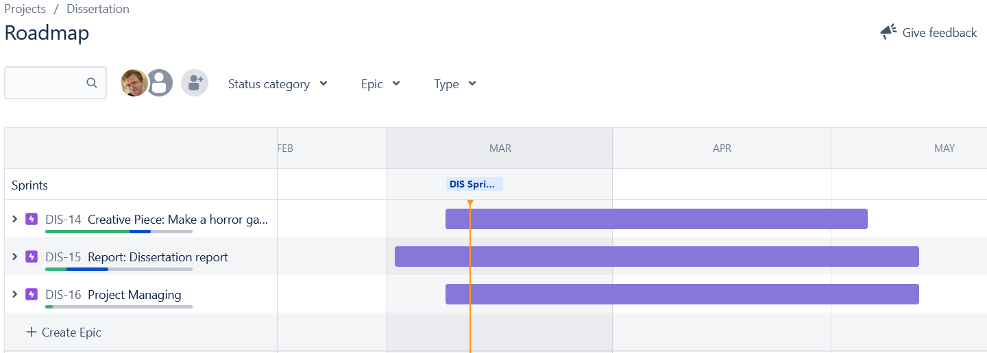

Fig 1.1: Jira Roadmap

Sprint 1 Summary:

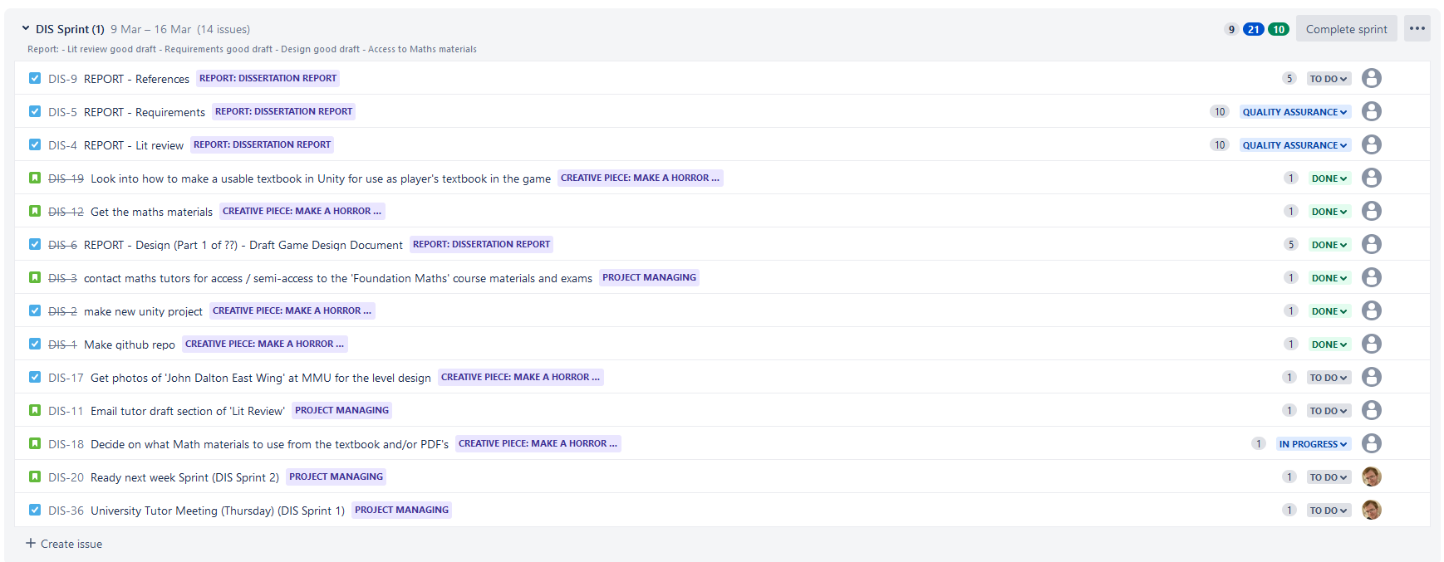

Fig 1.2: Sprint 1

Sprint 2 Summary:

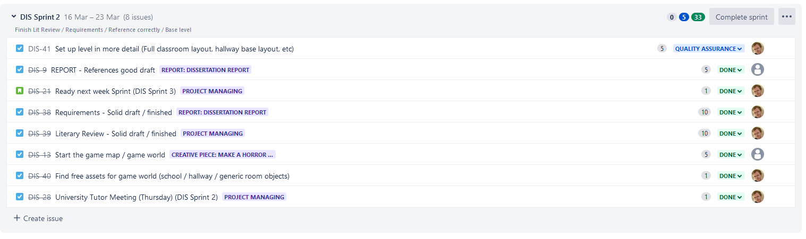

Fig 1.3: Sprint 2

Sprint 3 Summary:

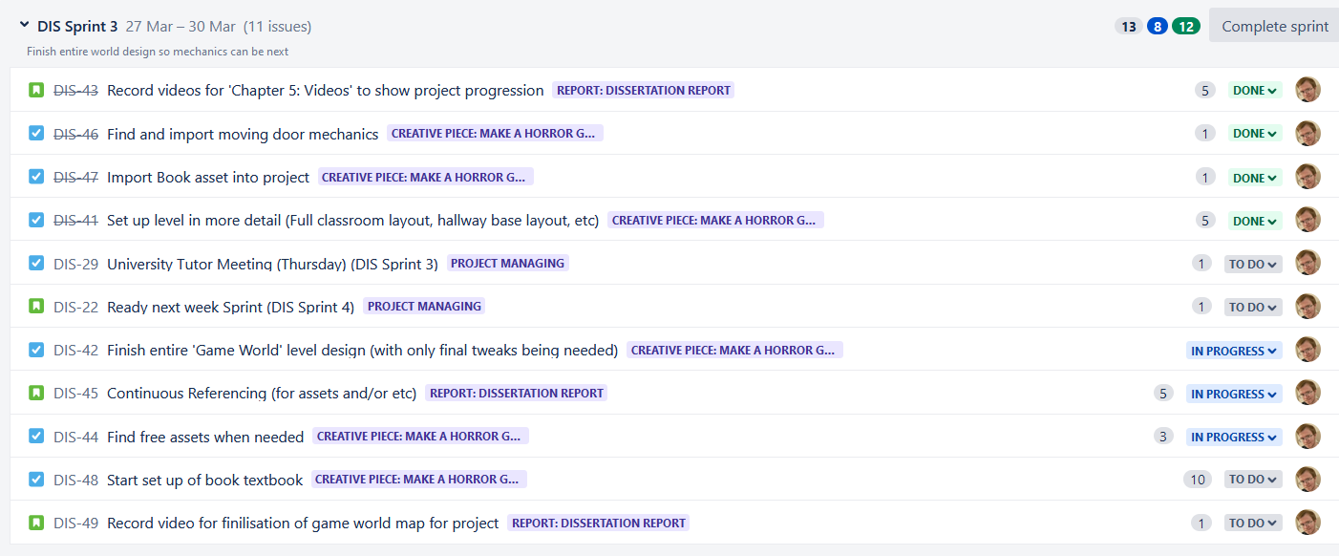

Fig 1.4: Sprint 3



Sprint 4 Summary:

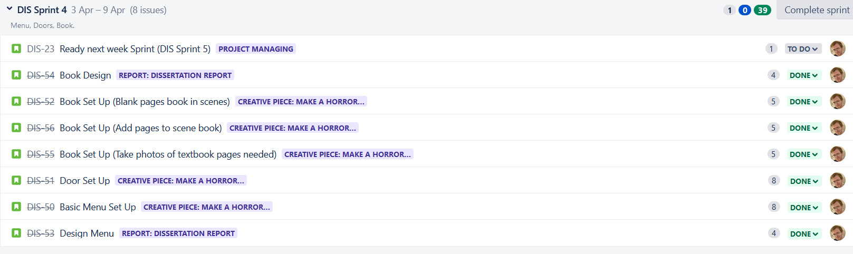

Fig 1.5: Sprint 4

Sprint 5 Summary:

Fig 1.6: Sprint 5

Sprint 6 Summary:

Fig 1.7: Sprint 6

Sprint 7 Summary:

Fig 1.8: Sprint 7

Sprint 8 Summary:

Fig 1.9: Sprint 8

Sprint 9 Summary:

Fig 1.10: Sprint 9

# Chapter 4 - Design

The game design was done over several stages, broken down into more details, and scribbled on paper over the course of a few days, spaces on the paper left for more details to be added if or when necessary.

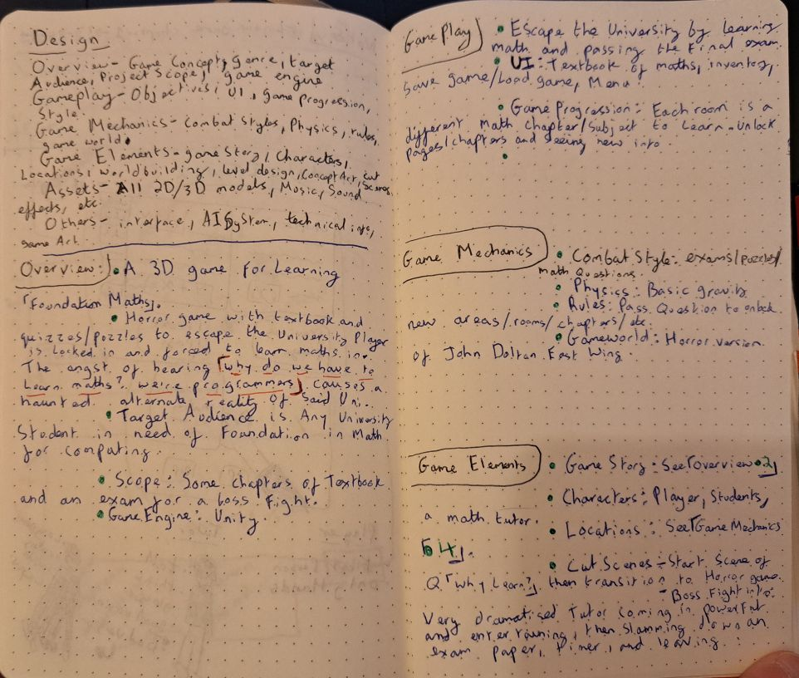4.1: Initial Design Ideas (on paper):

Fig 1.11: Design on paper page 1

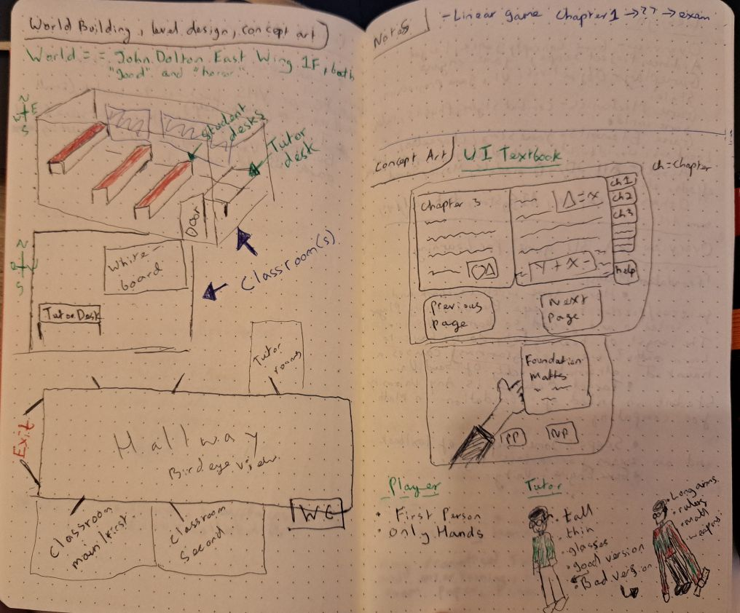

Fig 1.12: Design on paper page 2

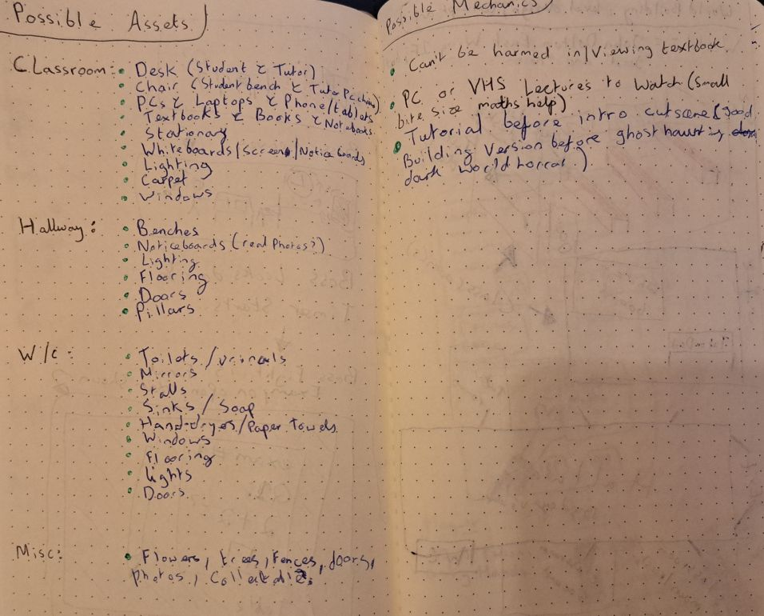

Fig 1.13: Design on paper page 3

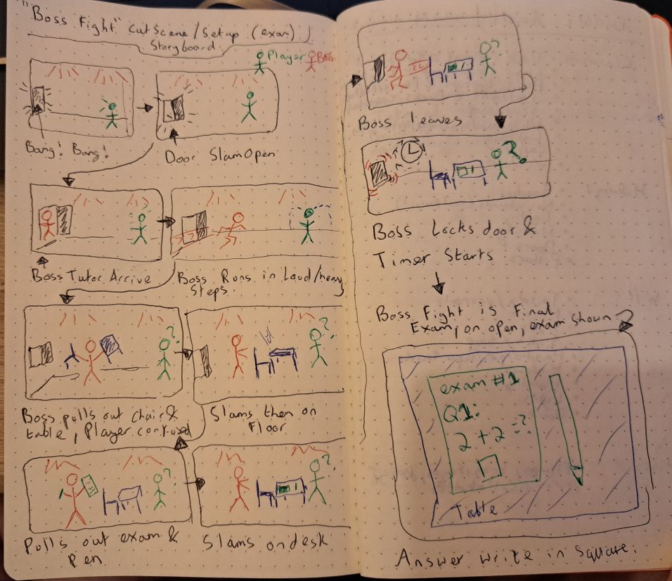

Fig 1.14: Design on paper page 4

4.2: The game world in Unity

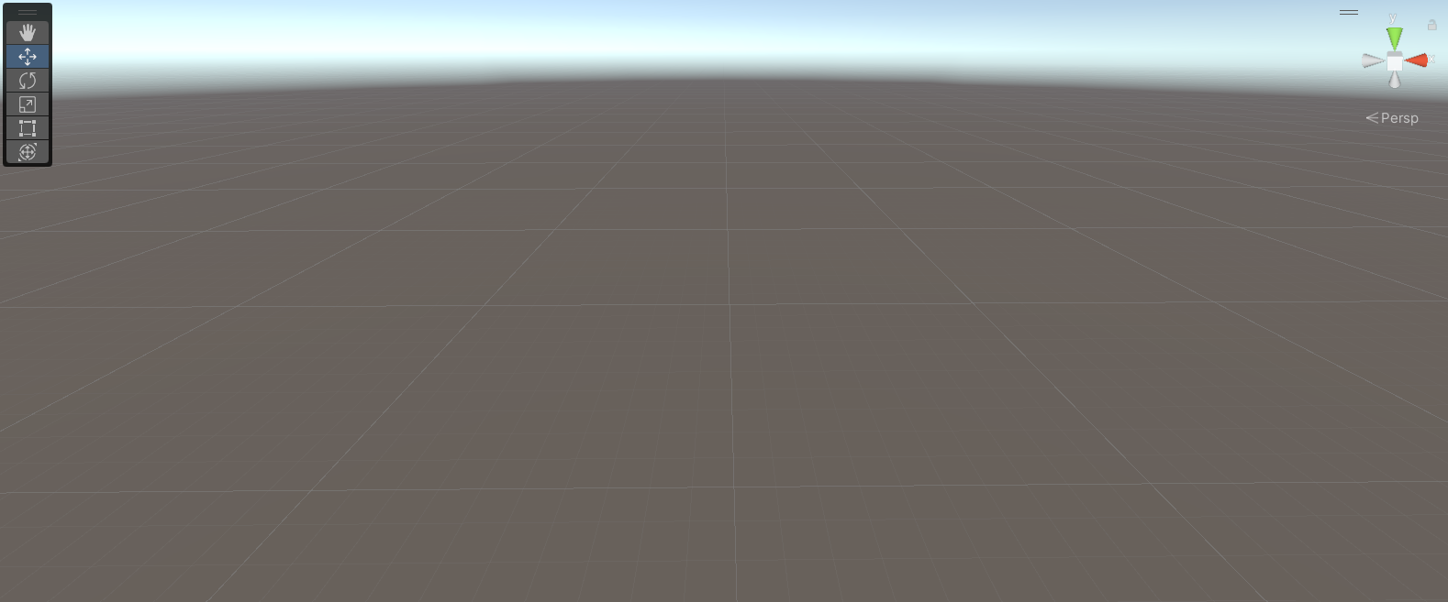

Fig 1.15: Empty Unity project starting point

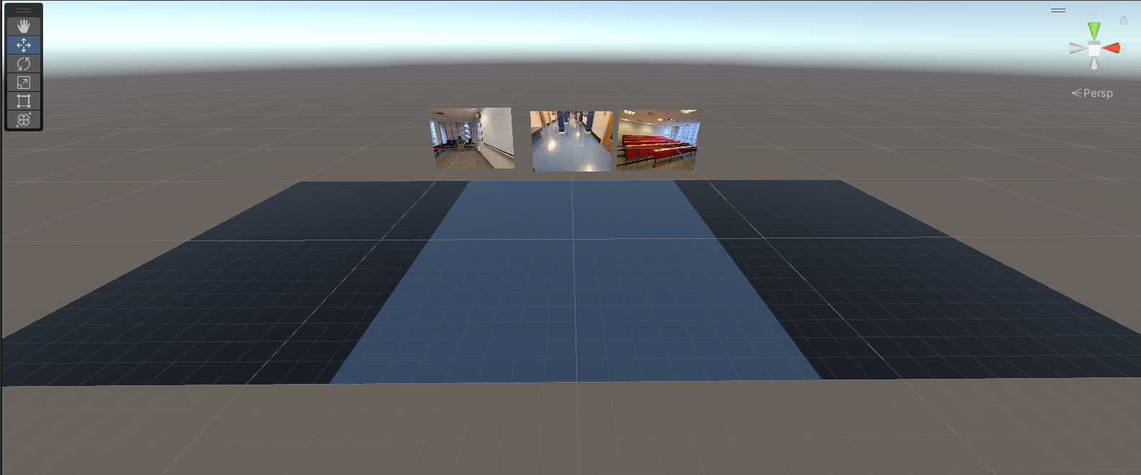

Fig 1.16: Floor layout with reference photos of JD East Wing

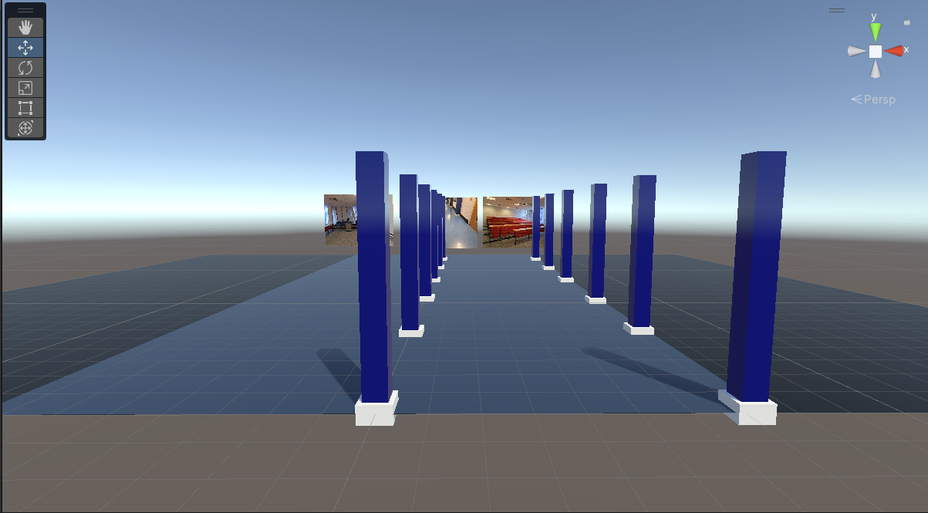

Fig 1.17: Adding the pillars as seen in JD East Wing

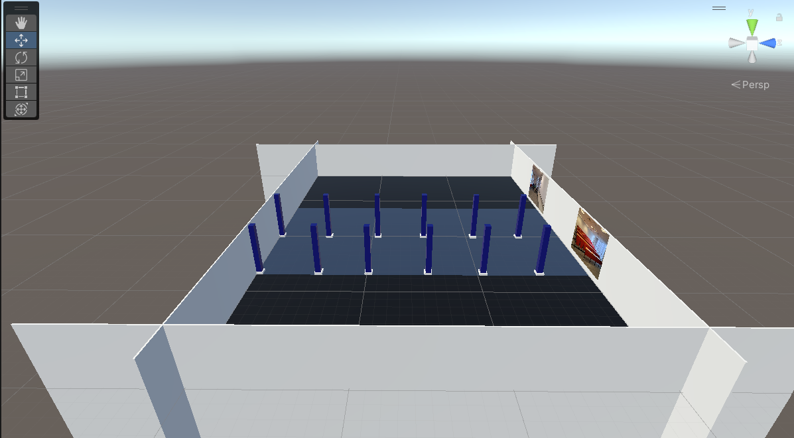

Fig 1.18: Outer walls to stop ‘out-of-bounds’

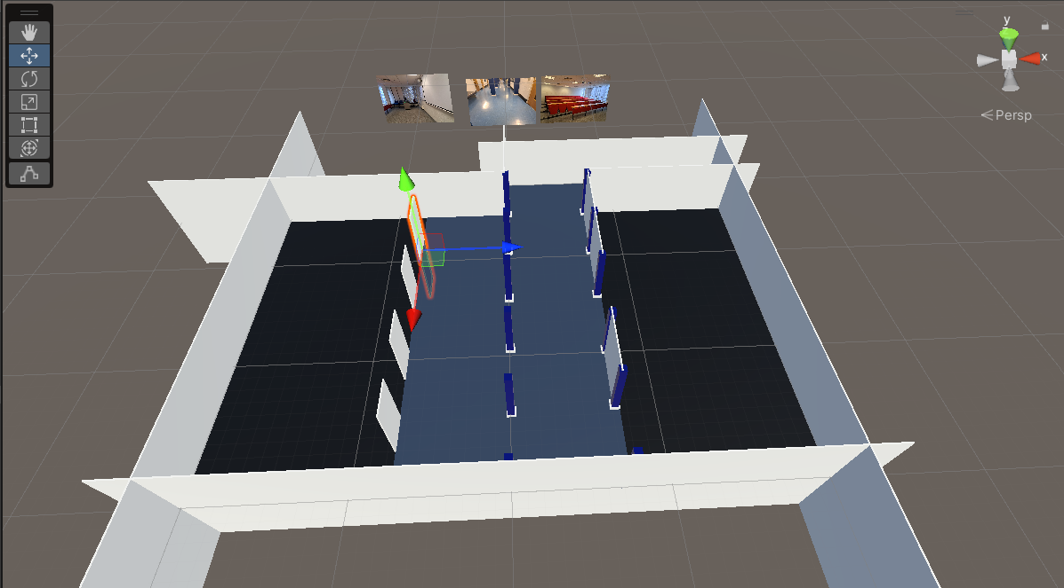

Fig 1.19: Adding more detail to walls

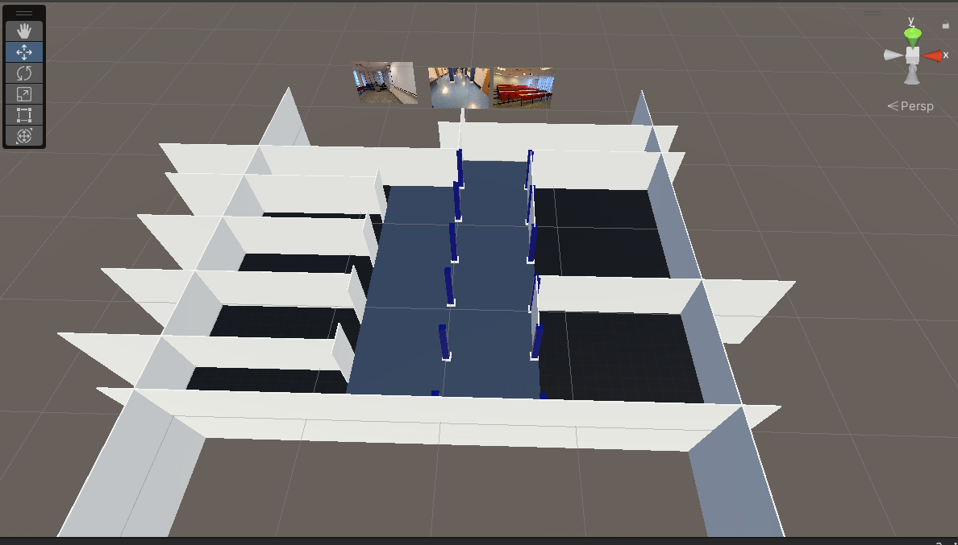

Fig 1.20: Walls of offices and two classrooms (E145, E147) set out (draft)

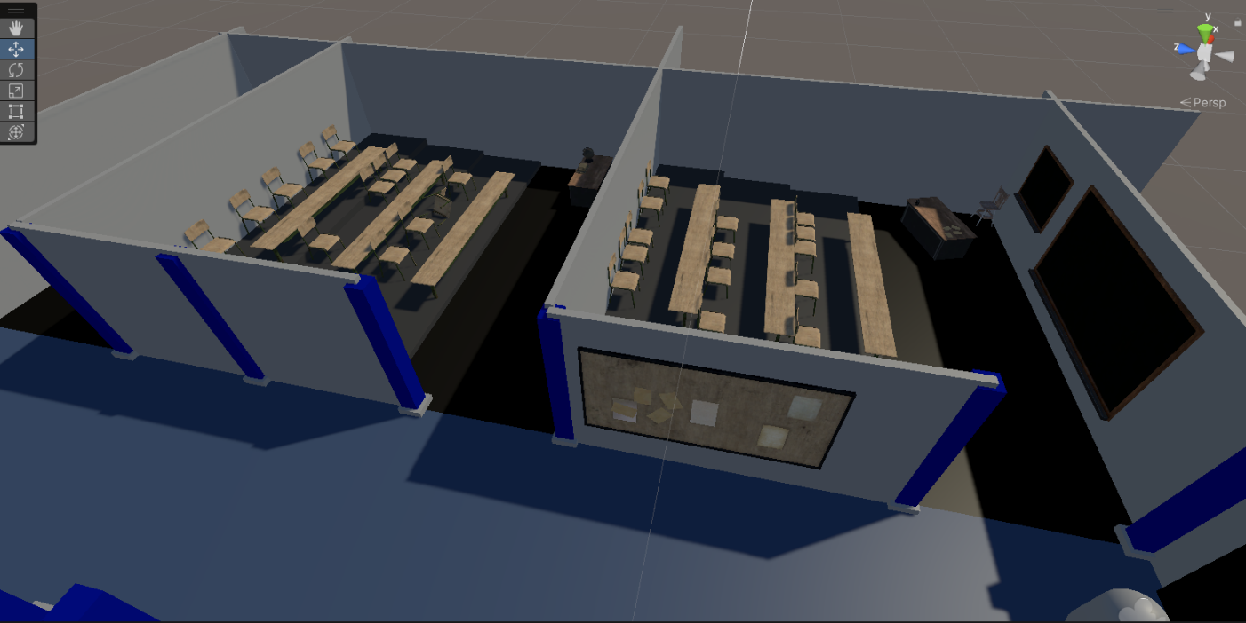

Fig 1.21: Level design of classrooms taking shape (finalising sizes, adding the incline in E145, E147, etc)

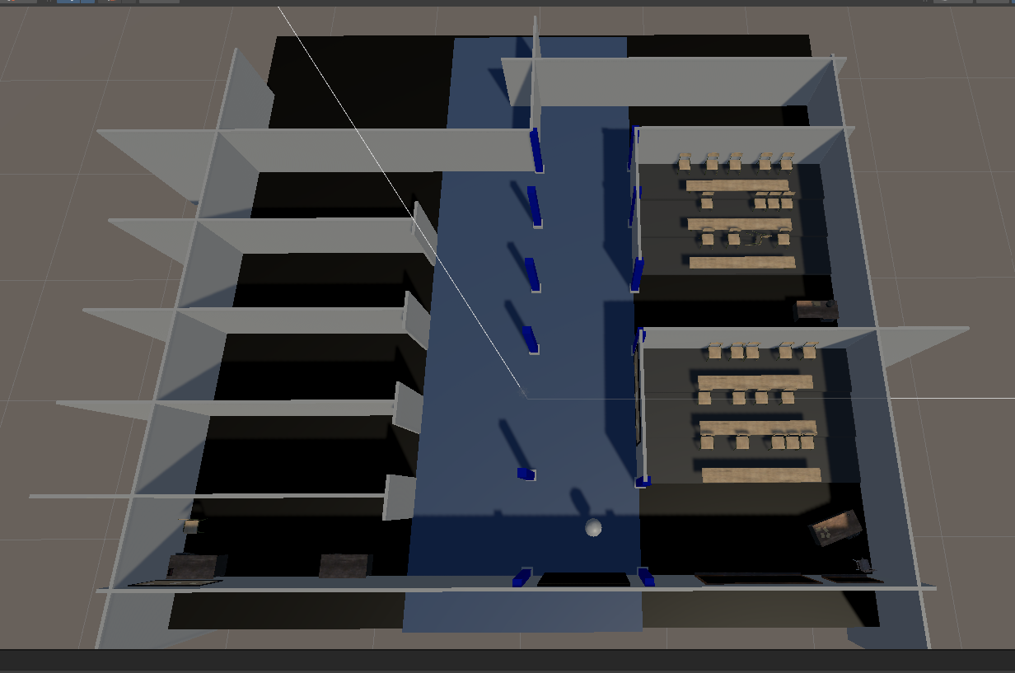

Fig 1.22: Birds-eye-view of progression

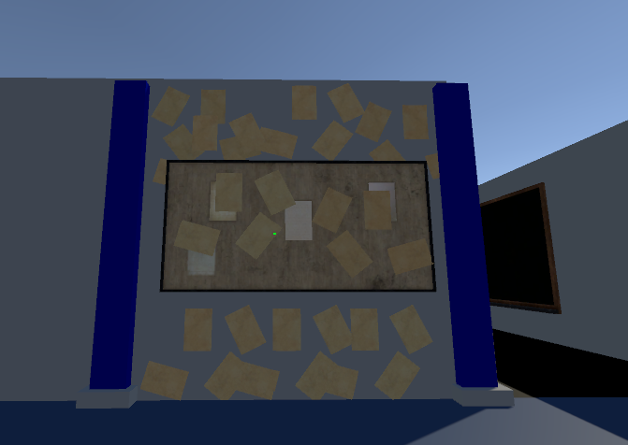

Fig 1.23: Ideas for “spooky walls” settings

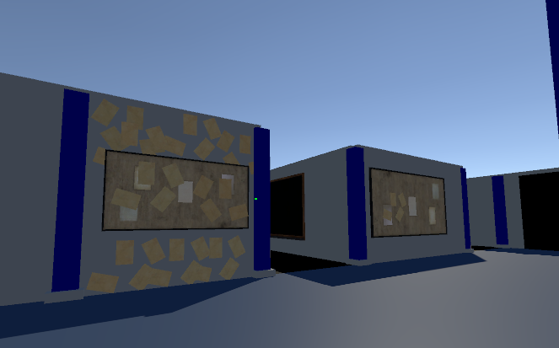

Fig 1.24: Expanding on “spooky walls” genre and theme

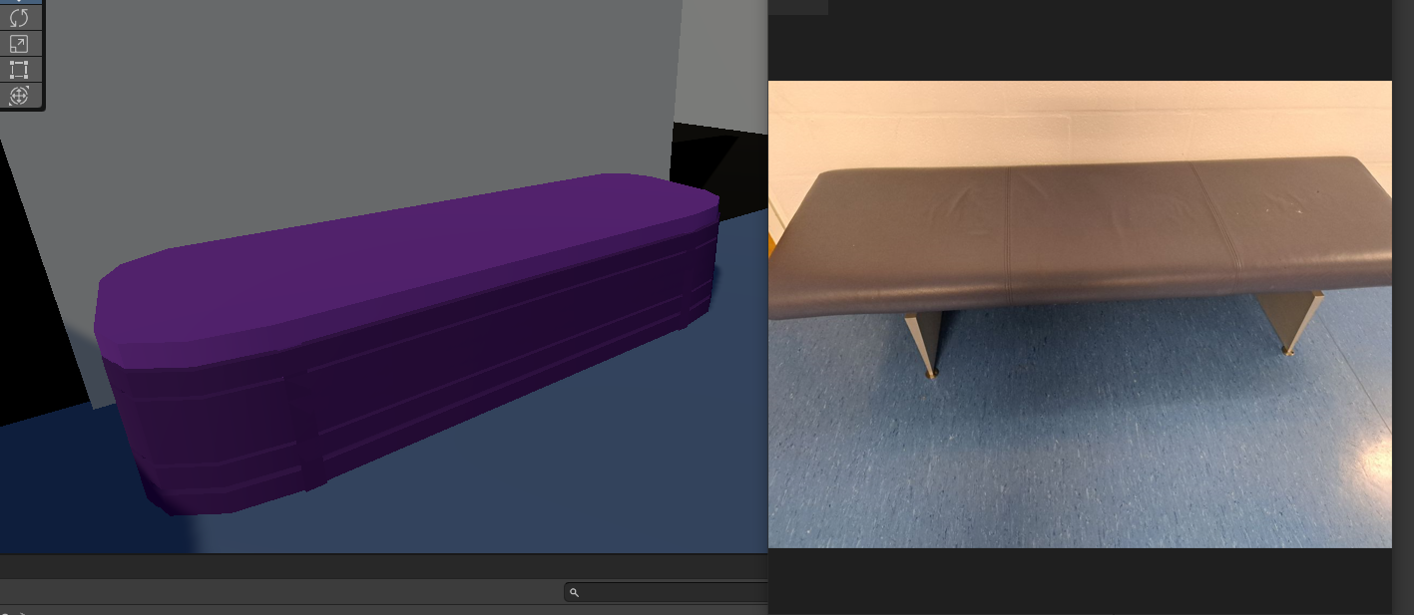

Fig 1.25: Using multiple tables to represent the benches in JD East Wing with reference picture

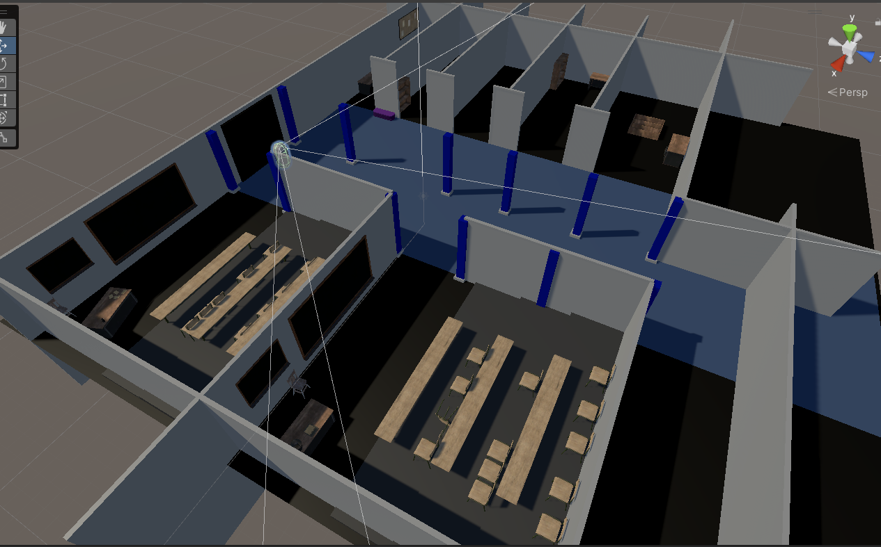

Fig 1.26: Good base Teacher desk, student desks, chairs, room layouts, and some office décor for draft level design

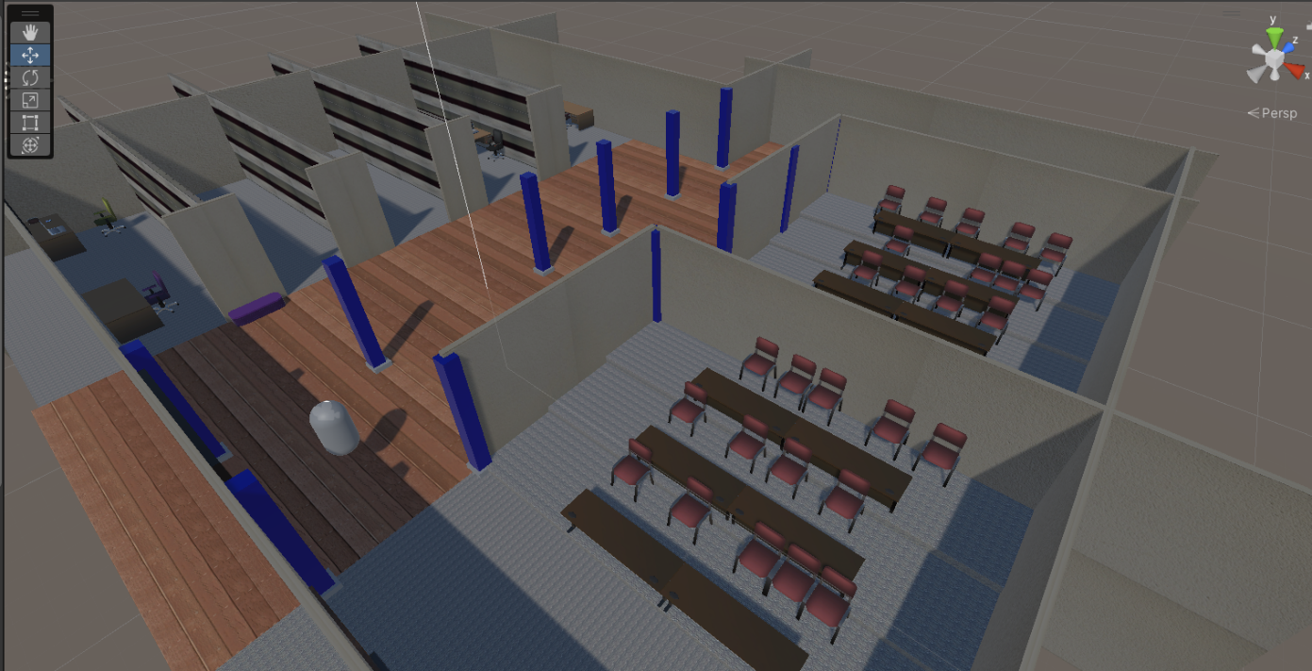

Fig 1.27: Base layout for MMU_Good Scene (the good / real world MMU JD East Wing)

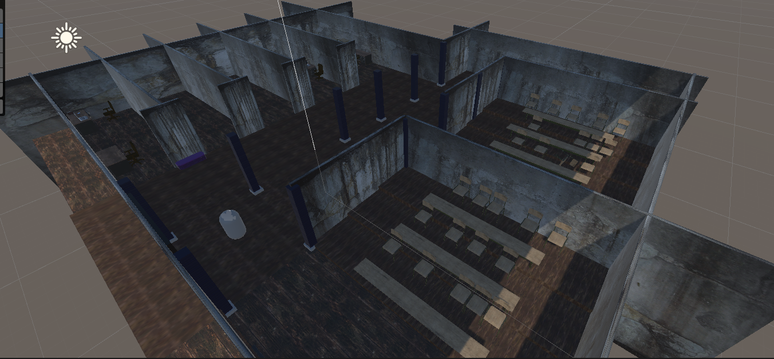

Fig 1.28: MMU_Evil Scene (the horror version of MMU JD East Wing) base layout

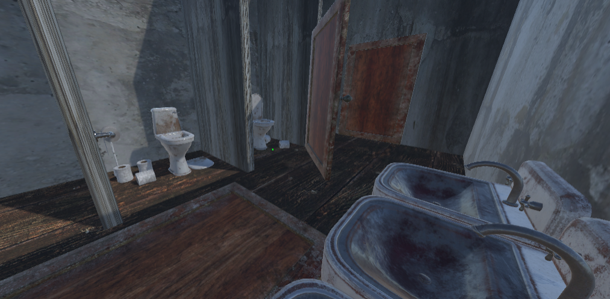

Fig 1.29: MMU_Evil bathroom

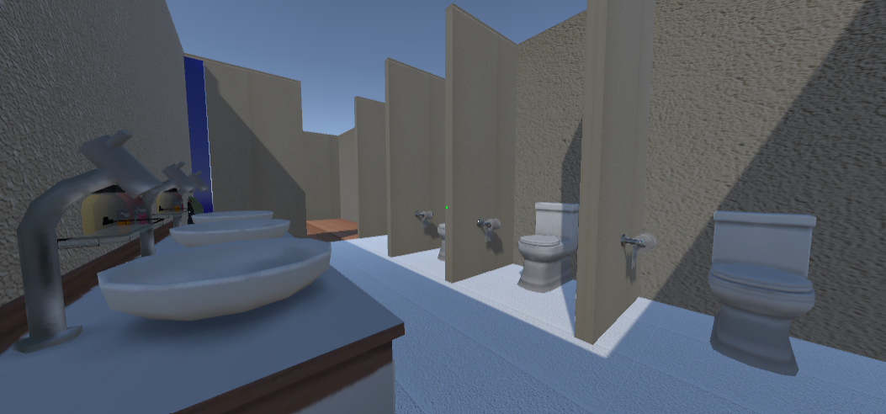

Fig 1.30: MMU_Good bathroom

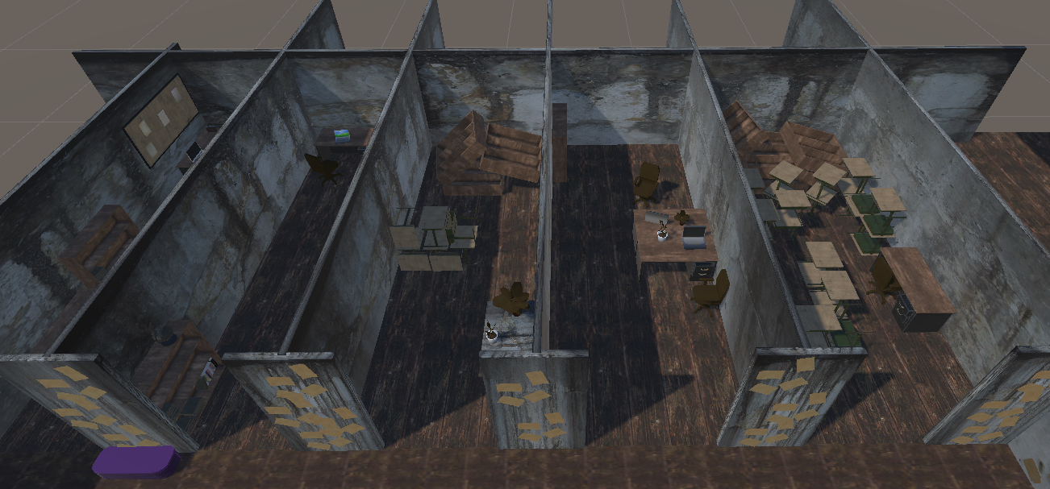

Fig 1.31: MMU_Evil offices set up

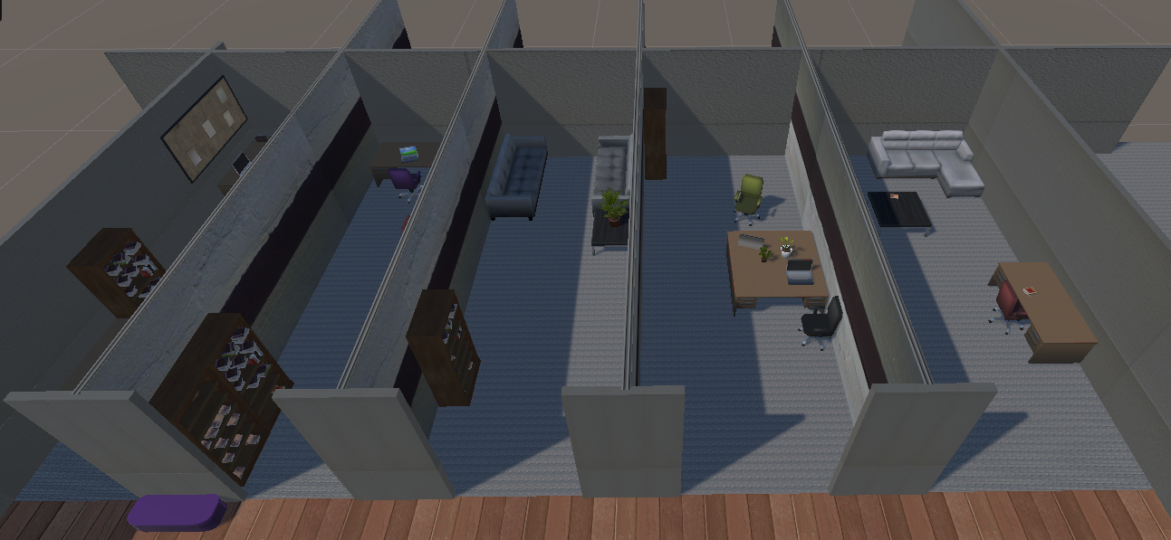

Fig 1.32: MMU_Good offices set up

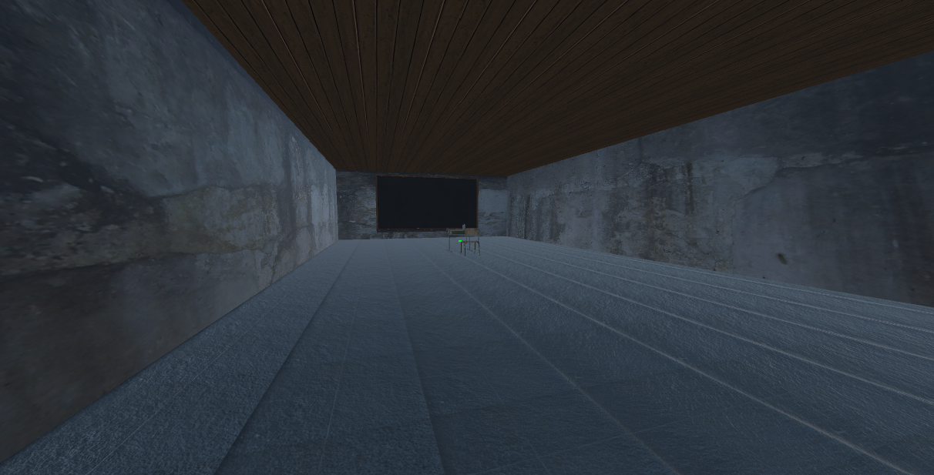

Fig 1.33: Exam room / Final Boss room

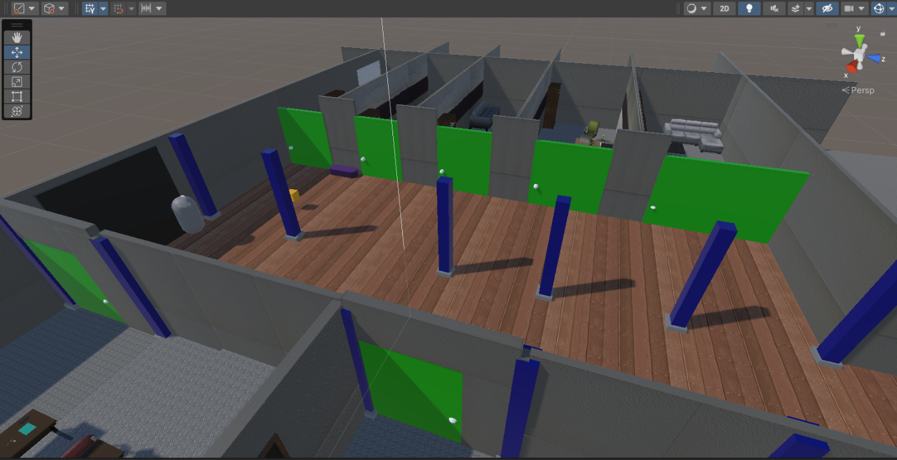

Fig 1.34: Doors (MMU_Good)

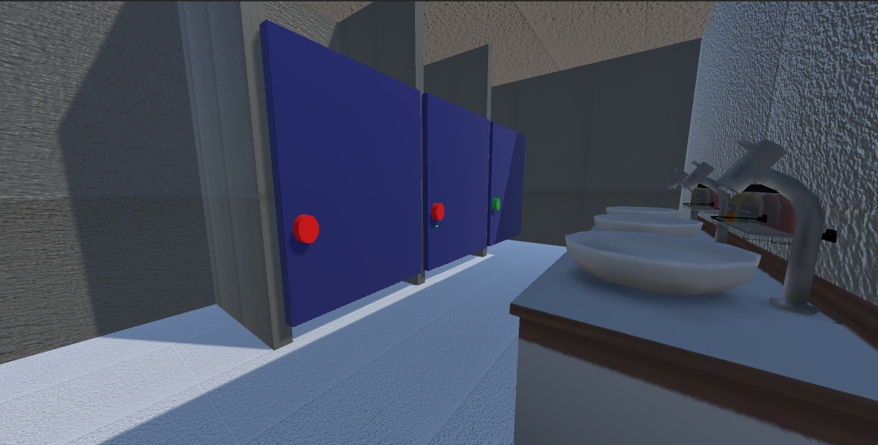

Fig 1.35: Toilet Doors (MMU_Good)

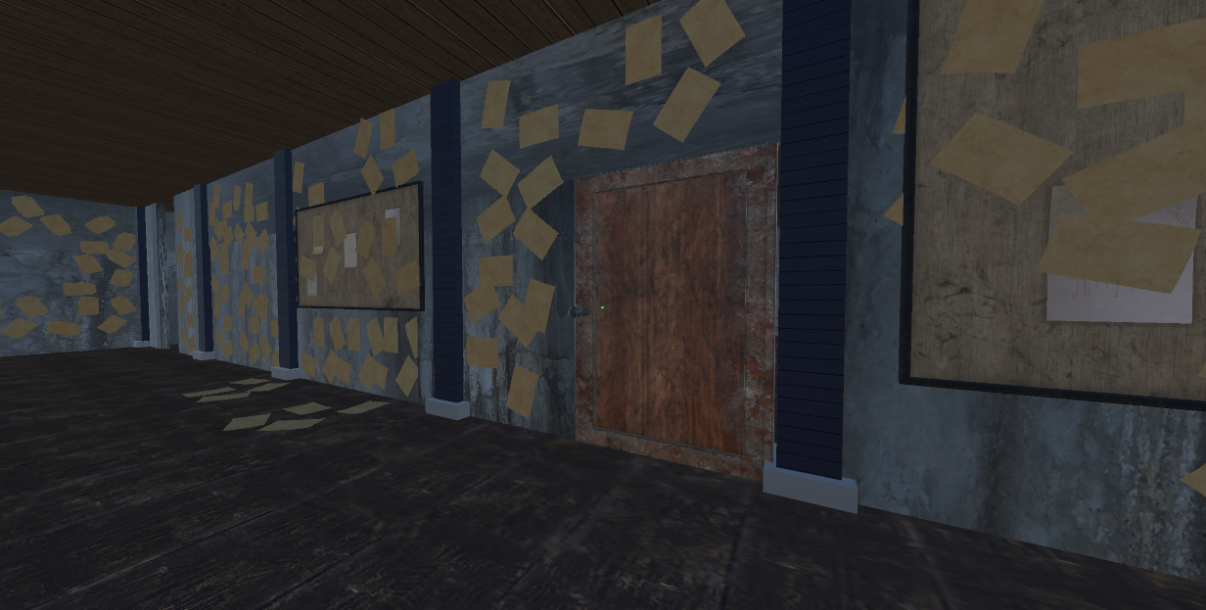

Fig 1.36: Doors (MMU_Evil)

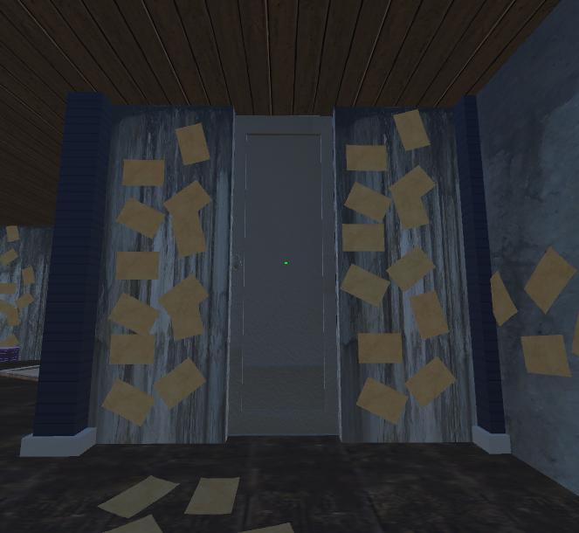

Fig 1.37: Final Boss Door (MMU_Evil)

4.4: Menu Design and Implementation:

There is only a need for a small and simple menu, including a play, options, credits, help/controls, and ability to quit the game.

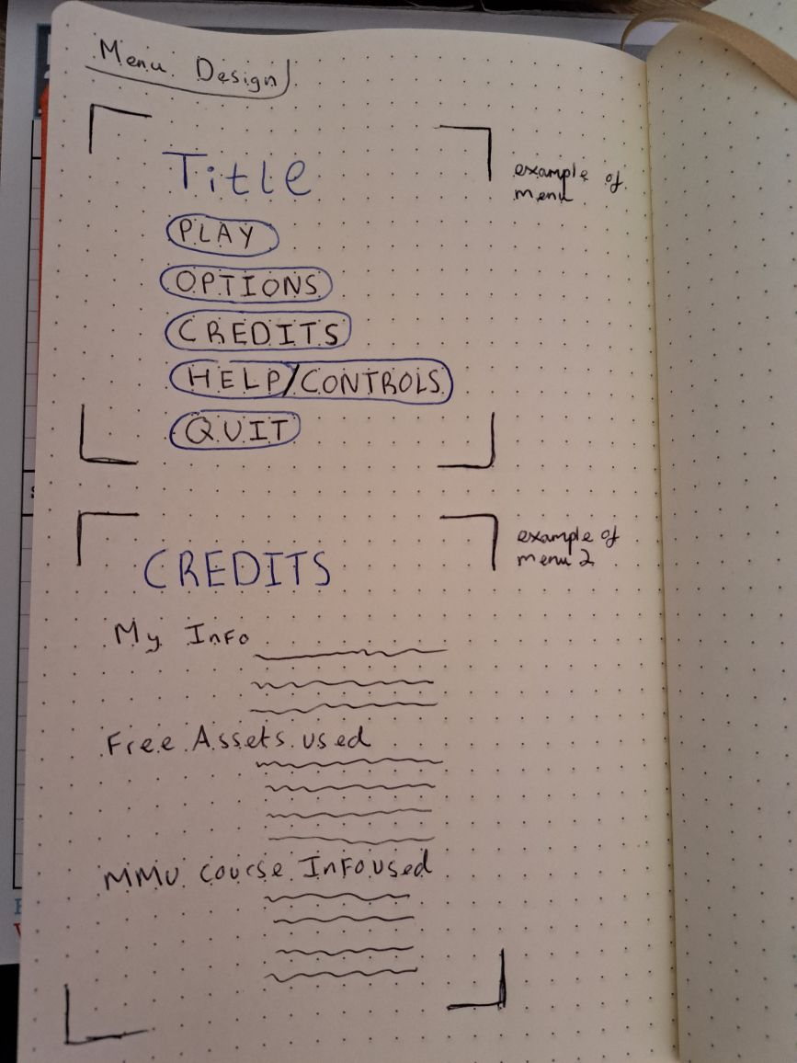

Fig 1.38: Initial menu design sketch



Fig 1.39: Example design of menu section

4.5: Design Extras:

Rotting wallpaper for walls in MMU Evil Scene: <https://www.dreamstime.com/royalty-free-stock-image-ruined-painted-wall-texture-image23841406>

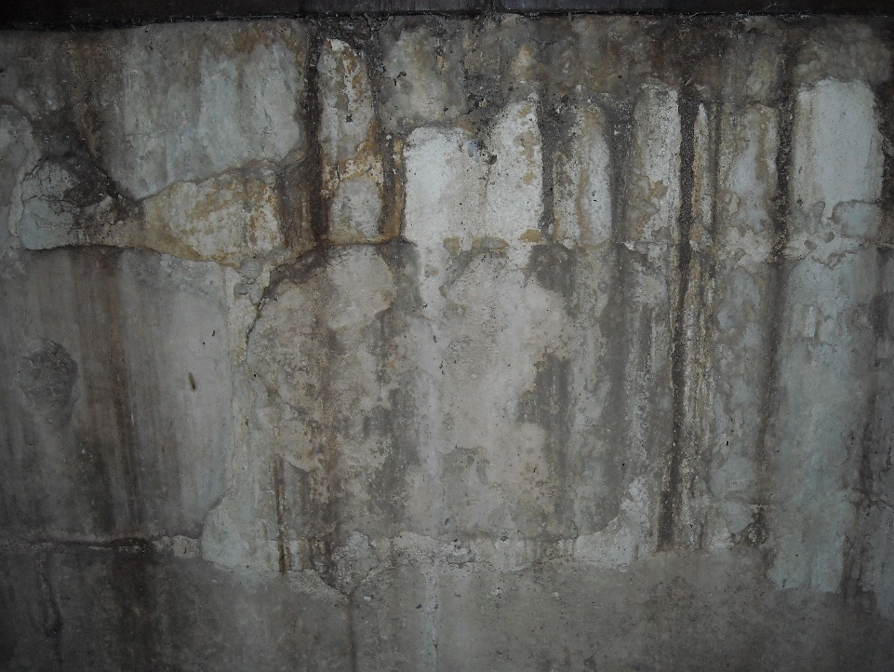

Flooring (for MMU_Evil Scene): <https://assetstore.unity.com/packages/2d/textures-materials/wood/plank-textures-pbr-72318>

Flooring / Walls (for MMU_Good Scene):

<https://assetstore.unity.com/packages/2d/textures-materials/nice-materials-pack-vol-2-67599>

Furniture assets:

<https://assetstore.unity.com/packages/3d/props/furniture/toon-furniture-88740>

Teacher assets (Horror Dummy):

<https://assetstore.unity.com/packages/3d/true-horror-dummy-67045>

# Chapter 5 - Videos

This section is for video updates of the entire process, from empty Unity project to completed concept, and video cutscenes from the final product.

5.1: Introduction Video of project and design:

<https://www.youtube.com/watch?v=jqlQf98U8nE>

5.2: Update on World map:

<https://www.youtube.com/watch?v=pLQTNRH055o>

5.3: Finalisation of world map:

<https://www.youtube.com/watch?v=cfmEvDIjYqA>

5.4: Door Failure:

<https://www.youtube.com/watch?v=TICrOJLVvYQ>

5.5: Working Doors:

<https://www.youtube.com/watch?v=DDntfMTs2vc>

5.6 Cutscene 1, the haunted doll placing the player into the horror game

5.7 Cutscene 2, the final boss room cutscene of the exam being set up

5.8 Cutscene 3, Good ending cutscene, returning to normal classroom and starting the day

5.9 Cutscene 4, Bad ending cutscene, failing the exam.

# Chapter 6 - Testing

6.1 Play Testing

6.2: Bugs and Fixes

|  |  |  |  |
| --- | --- | --- | --- |
| Number | Bug | Potential Fix | Comment/Evidence |
| #1 | Crosshair/cursor no longer works for textbook.  Textbook button click and/or trying to drag mouse to turn pages does not let you once you do an ‘Enforced Maths’ game. | 1.1 Change textbook from button to keyboard character to open?  1.2 But page flipping would need to be changed too, from a drag with mouse to a keyboard character press which is unwanted.  2.1 Change answering to be a button press instead of clicking on the correct answer | <https://www.youtube.com/watch?v=bsqfAcObmd4> |
| #2 | Page flipping on key press is glitched and unresponsive. | 2.1 May have to disable any other kind of method to flip pages, such as button presses, which fixed some of the issue #1 with the button being disabled and removed causing the ’T’ open/close function to work | <https://www.youtube.com/watch?v=5Uc7n-LlA9E> |
|  |  |  |  |
|  |  |  |  |

# Chapter 7 - Evaluation

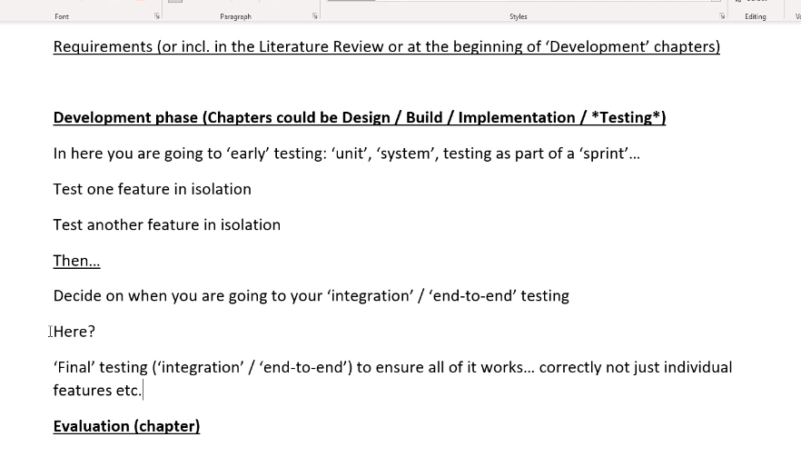

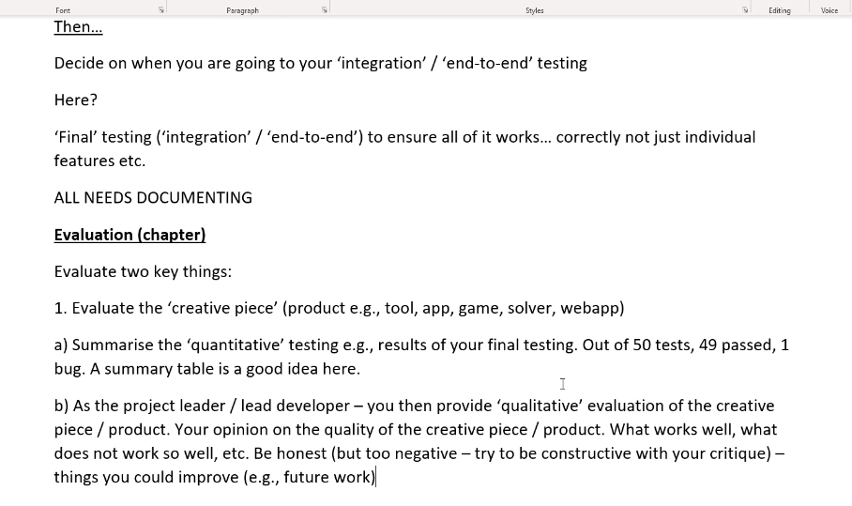

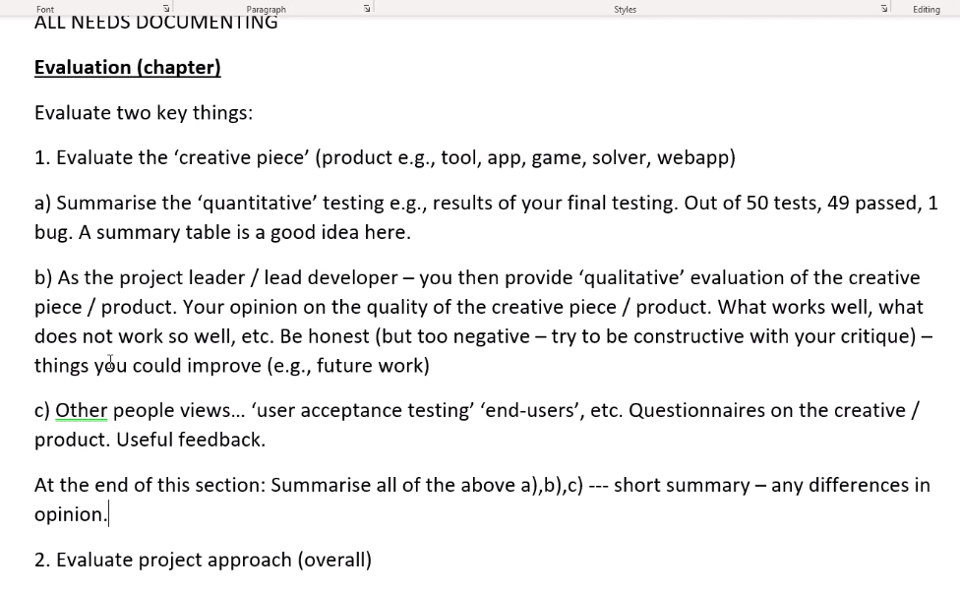

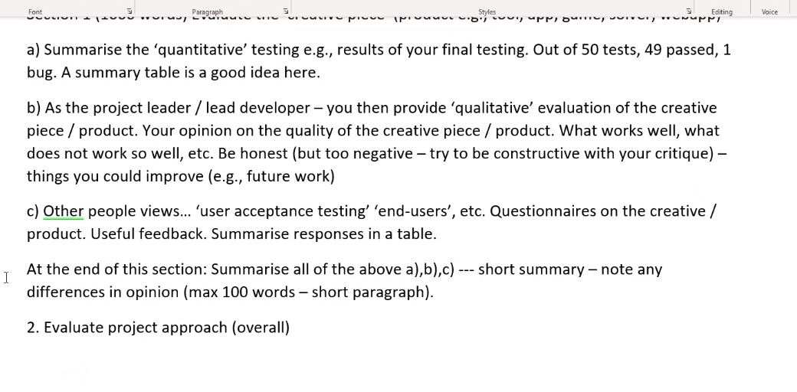

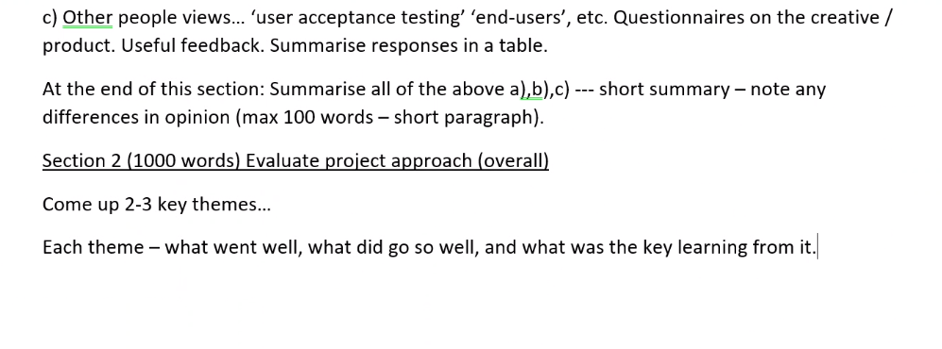

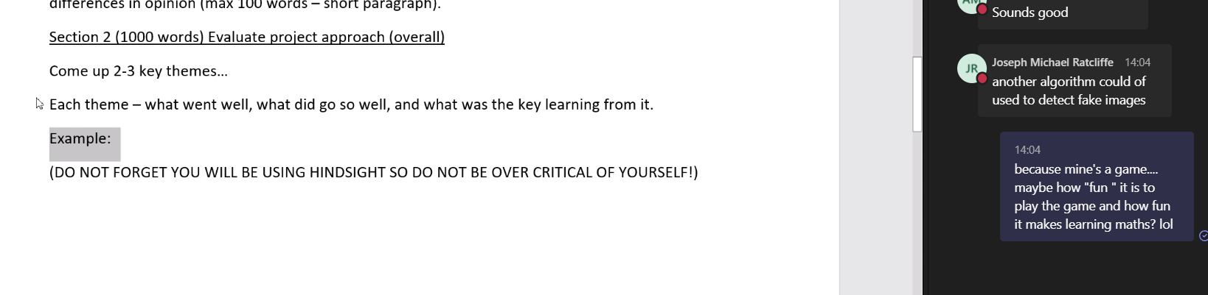

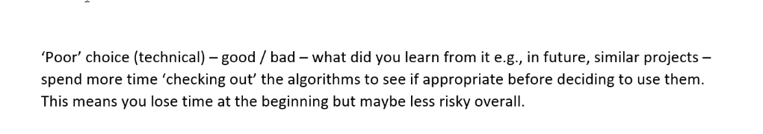

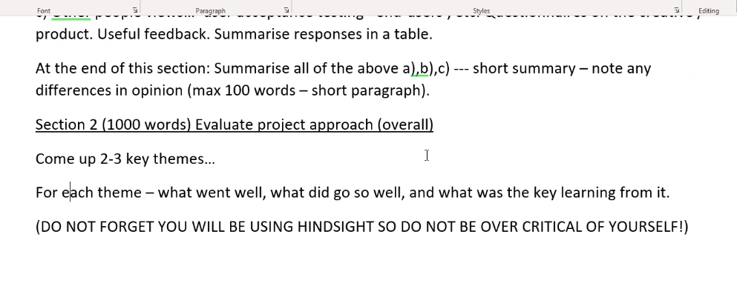

One

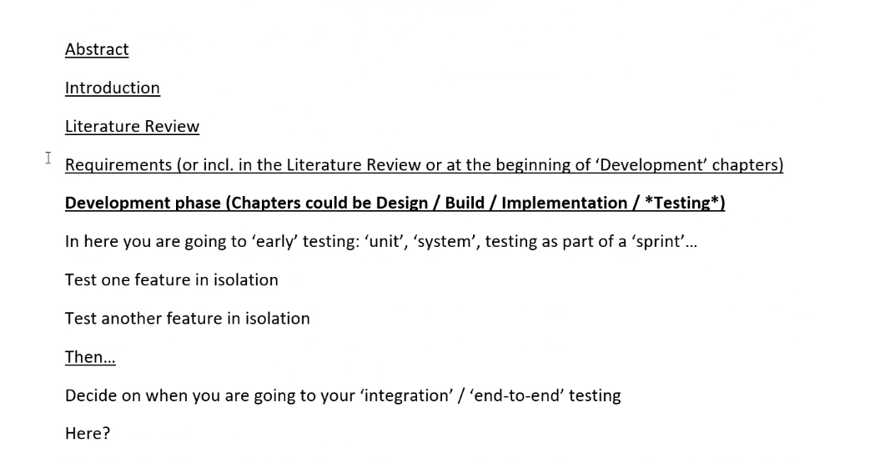

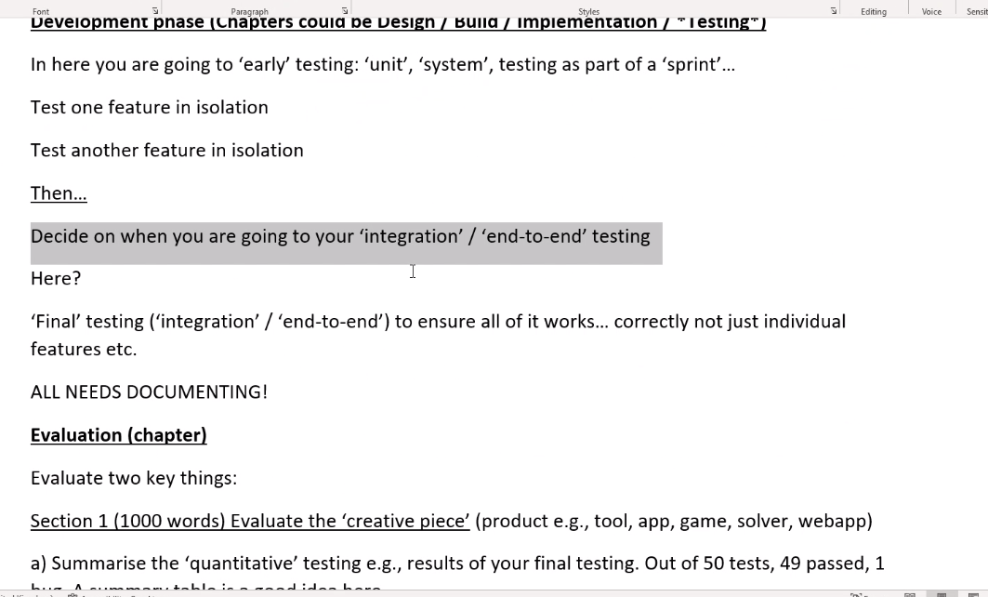

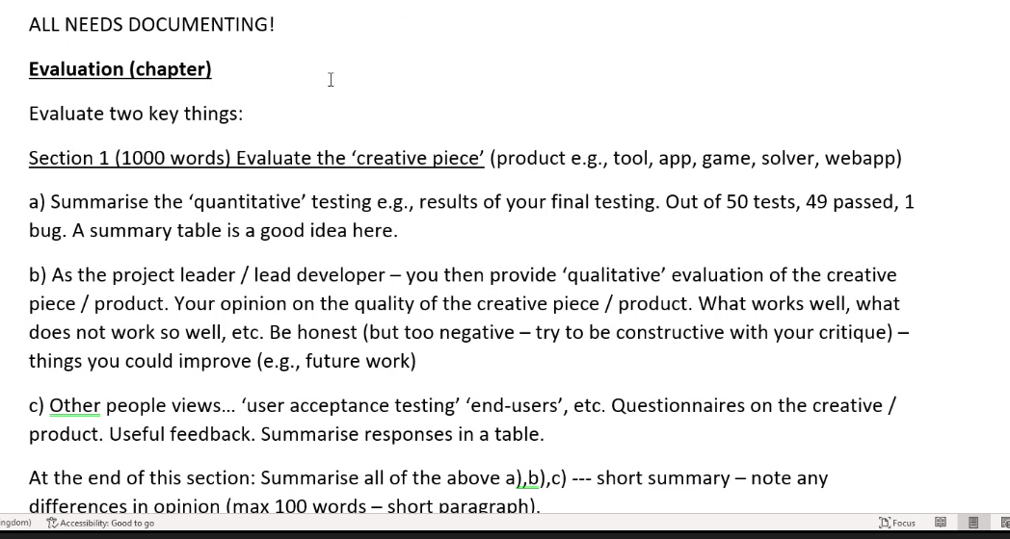

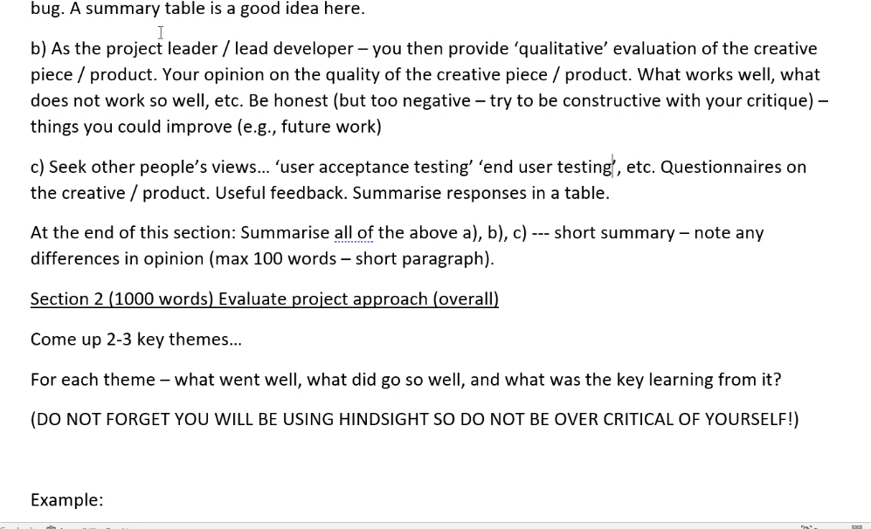

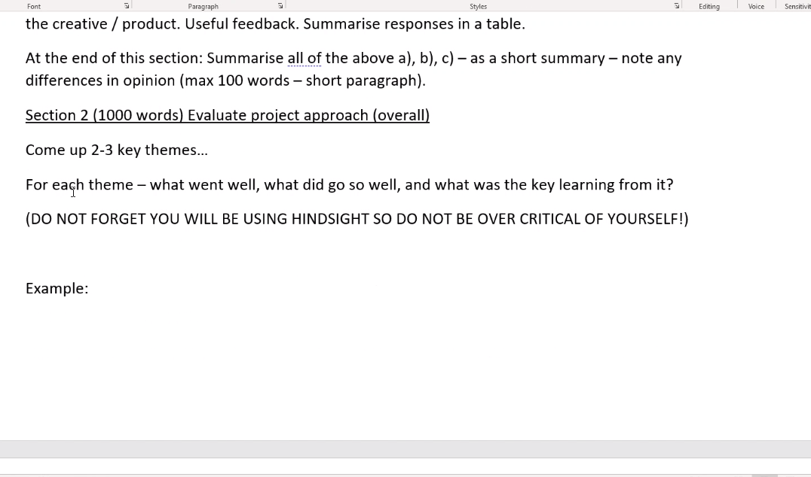

Project planning, time management, learning curves too steep etc. key thing what did you learn from it to be better in future

Mine is eval of product instead of project

Could I make it too fun where not learning much, or too boring where learning not fun, need balance.

# Appendix A

**The first appendix**

Include your Showcase materials (slides) he

# Appendix B

**The second appendix**

Include whatever is necessary here - code perhaps?

# Bibliography